Volunteer for Tinkerfest!

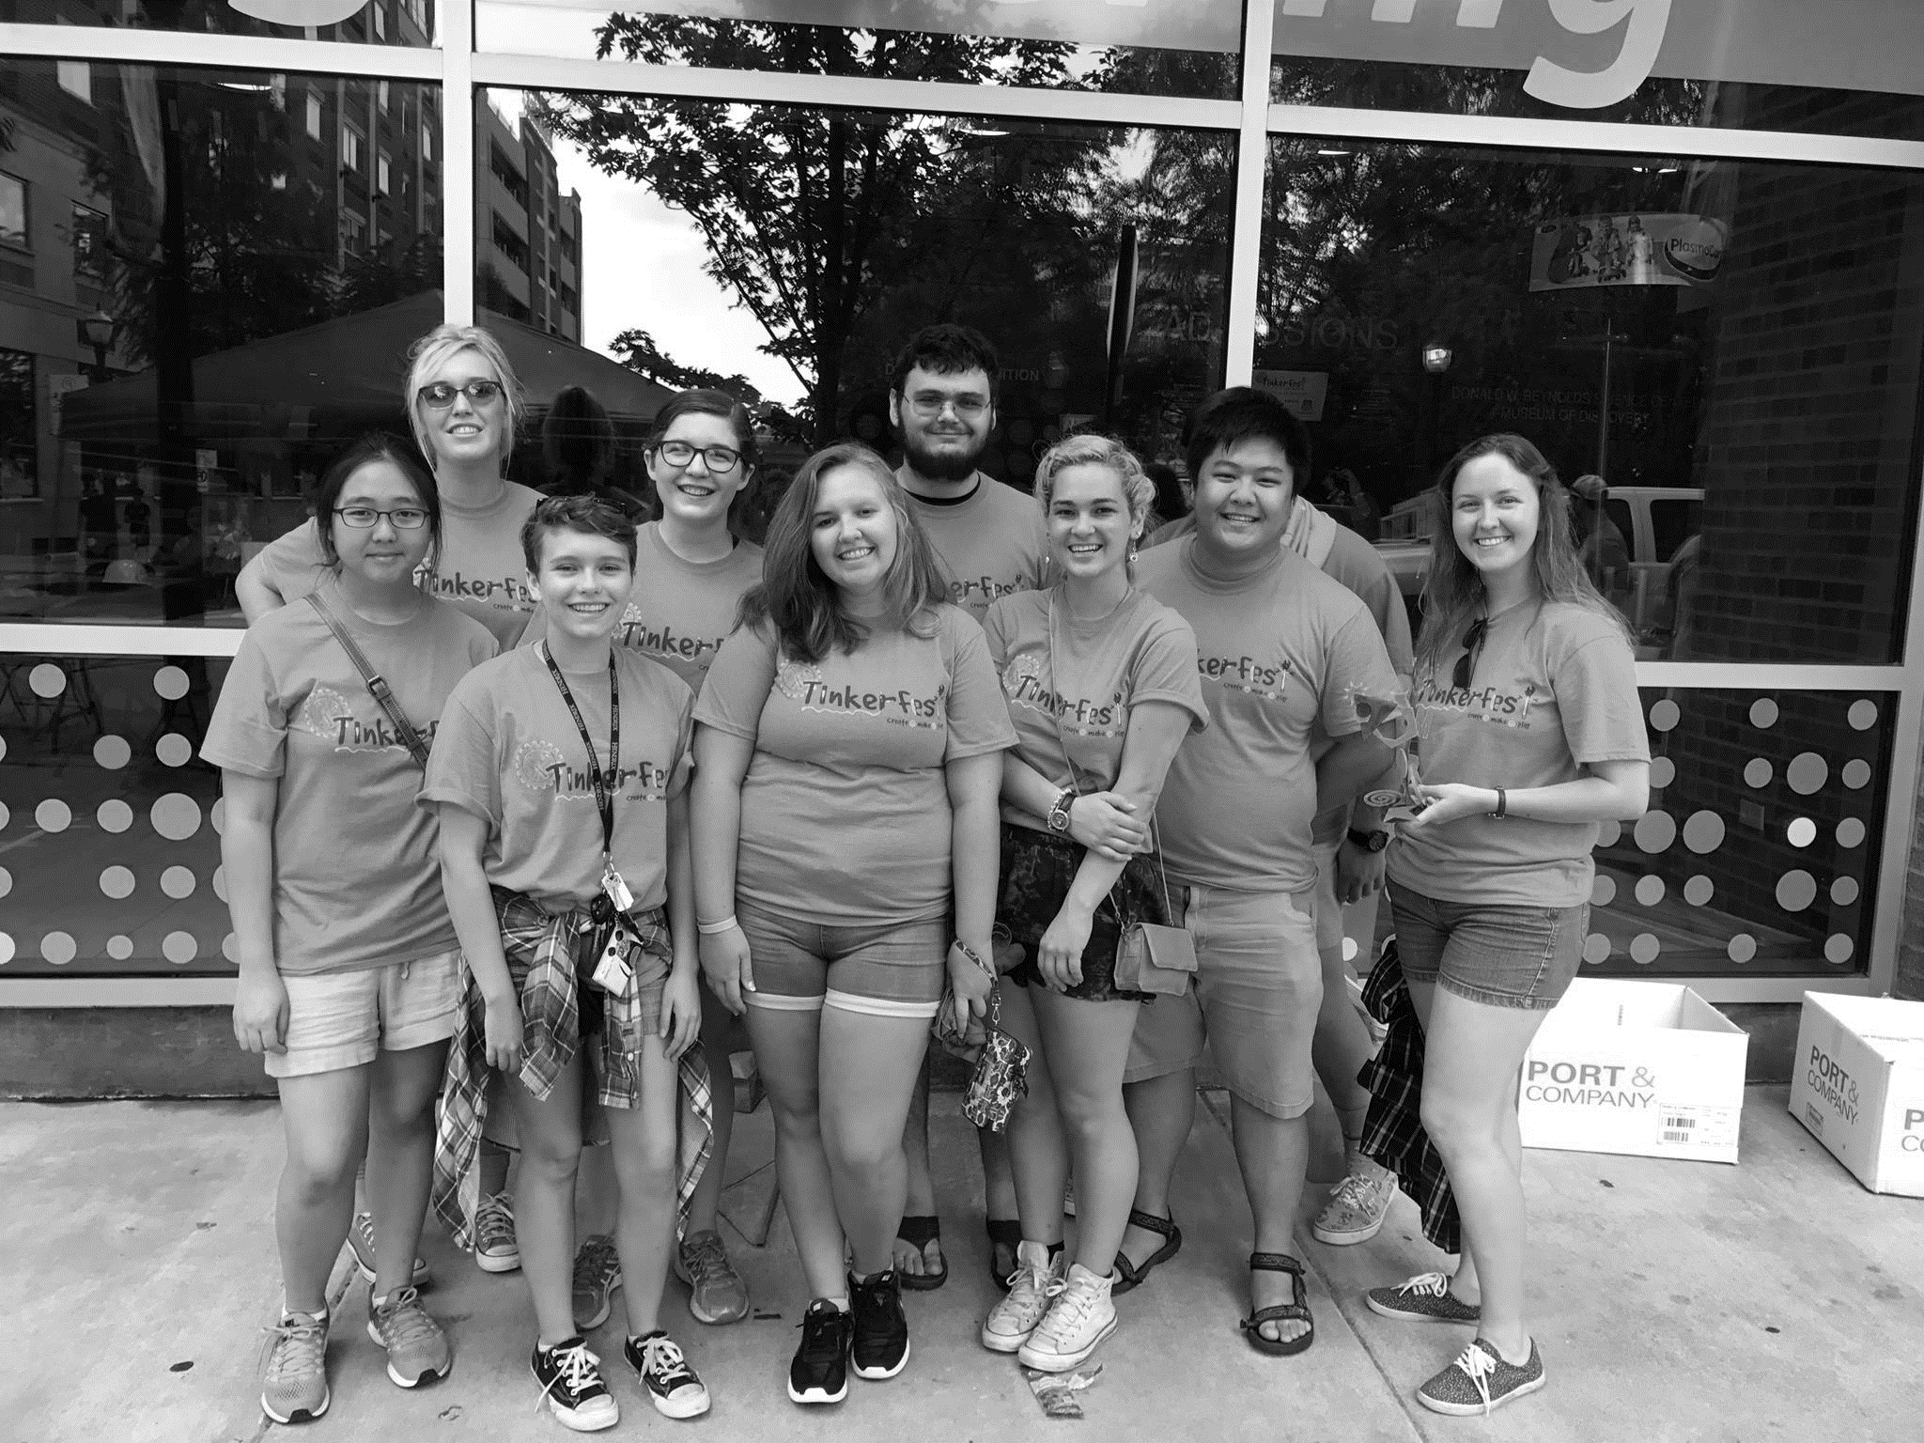

September __ 10:30 – 4:00

Tinkerfest is a family-friendly event that lets guests create, make, and play at 40 tinkering stations inside the Museum of Discovery and out on the closed-off street. Hendrix Computer Science Club will be helping with activities such as the car take-apart, PVC builds, and much, much more. In addition to having fun while teaching little kids about science, all volunteers get a free T-shirt and lunch (usually Mexican food)!

Email [_______@hendrix.edu](mailto:_______@hendrix.edu) to sign up